**Get particular visual**

visual = next(filter(lambda visuals: visuals['type'] == 'lineClusteredColumnComboChart', visuals))

**To display name of the chart**

visual_name = visual['name']

**Get the data**

summ_data = report.export_visual_data(active_page, visual_name, rows=10)

data = StringIO(summ_data)

df = pd.read_csv(data, sep=",")

df

|  | **Year** | **Quarter** | **Month** | **Day** | **Revenue** | **% Growth** |
| --- | --- | --- | --- | --- | --- | --- |
| 0 | 2013 | Qtr 1 | January | 15 | £1240958.2025 | NaN |
| 1 | 2013 | Qtr 1 | February | 15 | £1375329.365 | NaN |
| 2 | 2013 | Qtr 1 | March | 15 | £1848573.7275 | NaN |
| 3 | 2013 | Qtr 2 | April | 15 | £2151424.8375 | NaN |
| 4 | 2013 | Qtr 2 | May | 15 | £1930901.3325 | NaN |
| 5 | 2013 | Qtr 2 | June | 15 | £1931843.36 | NaN |
| 6 | 2013 | Qtr 3 | July | 15 | £1559326.555 | NaN |
| 7 | 2013 | Qtr 3 | August | 15 | £1629125.1925 | NaN |
| 8 | 2013 | Qtr 3 | September | 15 | £1773450.91 | NaN |

**Convert to Numeric**

df["Revenue1"] = pd.to_numeric(df["Revenue"].replace({r'\£':''}, regex = True))

df

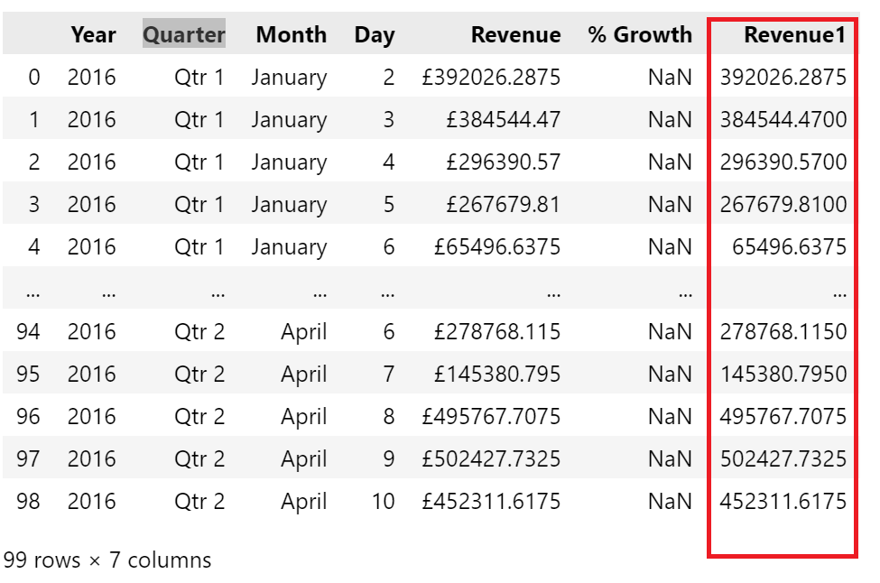

**Install matplotlib for get the visual chart**

pip install -U matplotlib

import matplotlib.pyplot as plt

**Group by Country**

df1 = df.groupby('Country')["Revenue1"].sum()

df1

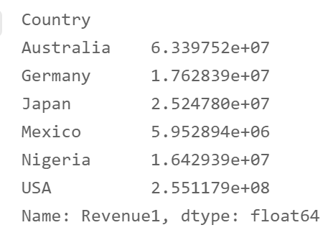

df1.plot(x='Country', y='Revenue1', kind = 'bar')

plt.show

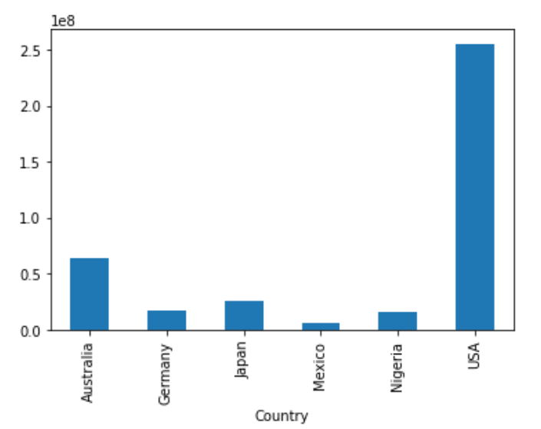

**Group by State and filter by country - Japan**

df2 = df[df.Country == "Japan"].groupby('State')["Revenue1"].sum()

df2

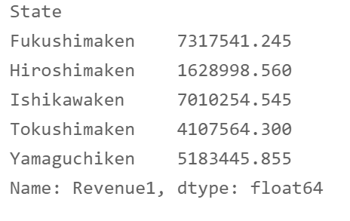

df2.plot(x='State', y='Revenue1', kind = 'bar', title="Japan")

plt.show

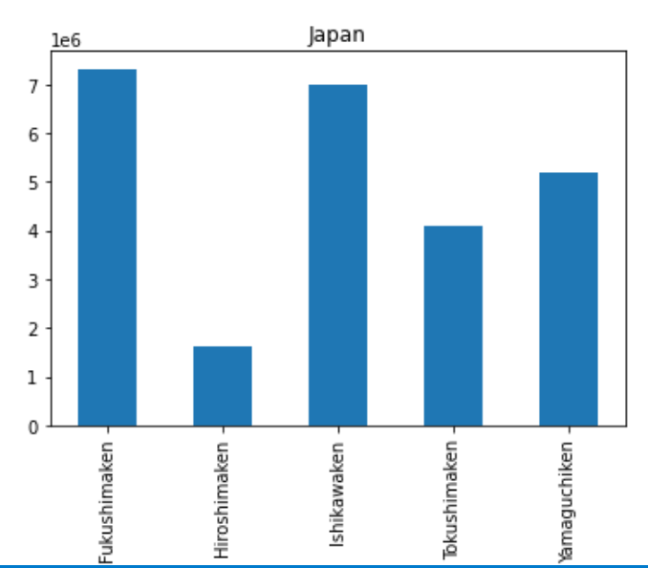

**Create filter to interact**

def filter_report(Year):

    year_filter = {

        '$schema': "http://powerbi.com/product/schema#advanced",

        'target': {

            'table': "hate_crime-csv-2-csv",

            'column': "Year"

        },

        'operator': "In",

        'values': [Year]

    }

    report.remove_filters()

    report.update_filters([year_filter])

from ipywidgets import interact

interact(filter_report, Year = ['2013', '2018'])

Get

report